Sprint1 - Jira - stripe-provider-service git setup - Working with Spring Profile
(WEEK3-DAY1)

✅ WEEK 3 – SPRINT 1 (Feb 16 – Feb 27)
🔹 What is a Sprint?
- 2-week working cycle
- Team decides how many features they can complete
- Daily work → Move tasks across board → Deliver fully working features
- Day 1 = Sprint Planning Meeting

🛠 1️⃣ JIRA SETUP (Mandatory First Step)
Create Project
- Create free Jira account (Gmail login)
- Use Scrum template
- Give proper project name
Create Sprint
- Go to Backlog
- Create new sprint → Feb26 Sprint1
- Set start & end dates
- Define sprint goal:
Setup Stripe Provider Microservice and integrate Create Order API
Add User Stories (Move to Sprint)
Add these as separate User Stories:
- Setup stripe-provider-service (with Maven + Profiles)
- Explore REST API & REST standards in Spring Boot
- Integrate Stripe CreateOrder API
- Implement Basic Auth during Create Order
- Error Handling in stripe-provider-service
- Incoming Notification / Webhook Handling
- Deploy stripe-provider in AWS & testing
- Add project in resume (Week 4 Day 5)
Start Sprint

🔹 Configure Board Columns
Default:
- TODO
- IN PROGRESS
- DONE
Add:
- QA
- WAITING FOR BUGFIX
Status Flow:
TODO → IN PROGRESS → QA → DONE
↓
WAITING FOR BUGFIX

🏗 2️⃣ Project Architecture Overview
Payment Integration Overview:
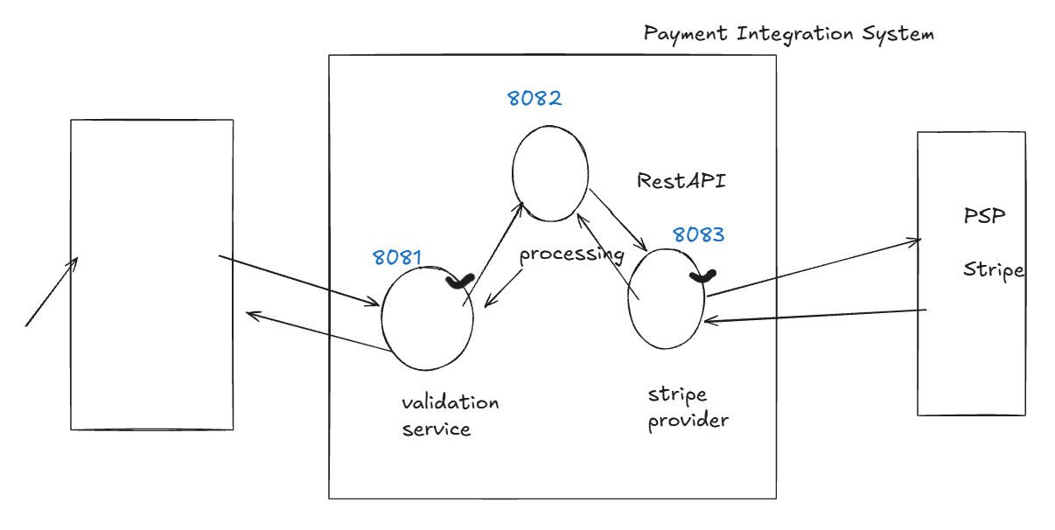

Payment Integration System (Microservices)
- Validation Service
- Payment Processing Service
- Stripe Provider Service ← (Focus this week)
Communication: REST APIs
Tech: Java + Spring Boot + Maven

🌿 3️⃣ Bitbucket Setup (Professional Workflow)
Create Repository
- Repo name = stripe-provider-service
- Create:
  - main branch
  - integration branch
Create Feature Branch
initial-service-setup
🚫 Never code directly in:
- main
- integration
Always:
Feature branch → Pull Request → Merge to integration

🖥 4️⃣ Local Setup Process (Very Important)
Now we want to clone the project, in last session we did this by going to sourcetree and then went to remote and cloned from there
Now, we will try second approach o clone the project. For this, go to bitbucket and go to feature branch in branches section and then -
- Checkout feature branch from Bitbucket in SourceTree
- Clone to organized local folder
Naming syntax –
Drive/mainprojectname/repofolder/microservice1name/featureofmicroservice
C:/PaymentIntegrationProject/repo/stripe-provider-service/stripe-provider-initial-setup

- Copy zip project code into clone location
- Import Maven project (not original zip folder)
- Run application
- Confirm:
  - Runs on correct port (8083)
  - Tomcat starts successfully
- Commit & push initial draft
- Raise PR → Merge to integration

📘 Stripe Provider Microservice – Setup Notes

Step 1: Requirement Comes
We need to build a new microservice:
stripe-provider-service
It will:
- Be a Spring Boot application
- Run independently
- Expose REST APIs
- Be packaged as a JAR
- Be part of a larger payment integration system

Step 2: Mentor Explains Real Company Scenario
Before touching code, mentor explained:
In real companies:
- The project already exists.
- Bitbucket repository is already created.
- main branch exists.
- integration branch exists.
- Basic Spring Boot structure is already available.
As a developer:
- You do NOT create project from scratch.
- You do NOT push directly to main.
- You do NOT push directly to integration.
You:
- Pick a Jira task.
- Create a feature branch from integration.
- Clone the repository.
- Work only inside the clone.
- Raise Pull Request.
- Get code reviewed.
- Merge after approval.
He was training us for real industry workflow.

Step 3: What Mentor Did Practically (Simulation)
Since we are learning, mentor simulated company setup:
- Created Bitbucket repository:
- stripe-provider-service
- Created:
  - main branch
  - integration branch
- Explained:
  - No direct coding in main
  - No direct coding in integration
  - Always create feature branch
Example:
feature/initial-setup
- Cloned repository locally.
This simulated real company environment.

Step 4: Getting Started Code
Mentor had a file:
stripe-provider-service-getting-started.zip
This was generated from start.spring.io with:
- Spring Boot 3.4.x
- Java 17
- Maven
This project contained:
- Only main Spring Boot application file
- No business logic
- pom.xml
- application.properties
- Base package:
- com.hulkhiretech
This represents company domain.

Step 5: Important Instruction Given by Mentor
He clearly said:
- Extract ZIP file.
- Copy project into cloned repository location.
- Import cloned folder as Maven project in IDE.
- Never code inside original ZIP folder.
Reason:
Git only tracks code inside cloned repository.
This ensures proper version control.

Step 6: Understanding Dependencies (Mentor’s Setup)
In pom.xml, mentor included:
During start.spring,io
- spring-boot-starter-web
→ For REST APIs
→ Includes embedded Tomcat
- spring-boot-starter-test
→ JUnit
→ Mockito
- DevTools
→ Auto restart on save
- Lombok
→ Reduces boilerplate code
Manually
- ModelMapper
→ DTO to Entity mapping
He explained:
Adding dependencies is usually a one-time setup activity for a microservice.

Step 7: Profiles Setup
Mentor project had multiple profiles.
Purpose:
- dev
- qa
- prod
Each environment can have:
- Different ports
- Different database configs
- Different credentials
This is production-level configuration concept.

Now — What We Did

Step 8: Our Approach
Instead of using mentor ZIP:
We decided to:
- Create our own Spring Boot project
- Use Java 21
- Use our own base package
- Add dependencies manually
- Follow same structure
This way:
We are not copying.
We are understanding and building ourselves.

Step 9: Our Repository Setup
We:
- Created our own Bitbucket repository.
- Created main and integration branches.
- Cloned repository locally.
- Generated new project from start.spring.io.
- Added it into cloned directory.
- Imported it as Maven project in IDE.
So we are following same process — but independently.

Step 10: Git Discipline (Same as Mentor Taught)
We will:
- Create feature branch from integration.
- Do coding in feature branch.
- Commit changes.
- Push branch.
- Raise Pull Request.
- Merge after review.
Even though we are working alone, we are following industry workflow.

Step 11: Build Process
After setup:
Run:
mvn clean package
It generates:
stripe-provider-service.jar
This JAR runs as independent microservice.

Final Understanding
Mentor was not just teaching:
- Spring Boot
- Maven
- Dependencies
He was preparing us for:
- Real corporate workflow
- Git discipline
- Feature branch culture
- Pull request process
- Jira tracking
- Microservice structure
- Production-ready setup thinking

Difference Summary
Mentor:
- Simulated company environment
- Used company package name
- Used Java 17
- Gave prepared ZIP
- Focused on industry discipline
We:
- Created our own project from scratch
- Used Java 21
- Used our own package name
- Added dependencies manually
- Still following same workflow

DOUBT : Logging Path – Why Does It Exist?
In production:
Applications run on servers.
Console logs are temporary.
So companies:
- Store logs in files
- Separate logs per microservice
- Allow DevOps to monitor issues
This property:
<logging.path>...</logging.path>
tells Spring Boot:
"Write log files in this folder."
What happens after this?
When app runs:
- A log file is created in that folder.
- Logs are written there.
- You can debug production issues later.
For learning?
Not mandatory.
But good habit.

Working with profile & environments
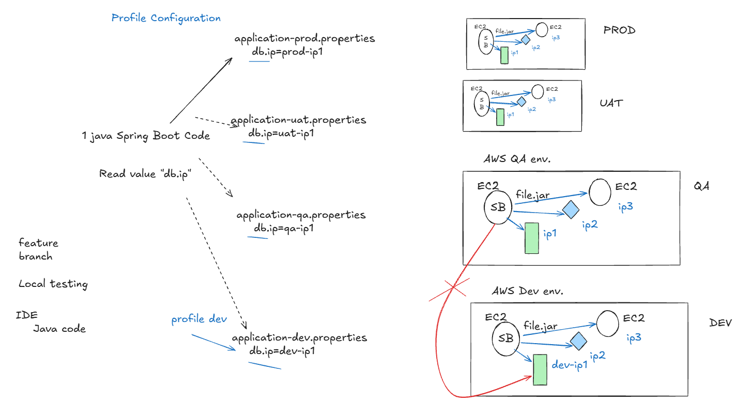

Profile
• A profile is a name given to a set of environment-specific configurations for your Spring Boot app
• Each environment (Dev, QA, UAT, Prod) has different machines like DB, Redis, etc., each with their own IPs
• When a microservice runs in an environment, it must connect only to services of that environment, never another environment’s services
• Profiles let the app handle this automatically using property files: application-<profile>.properties (e.g., application-dev.properties)
• Property files store environment-specific settings like DB IPs, Redis, other MS URLs
• At runtime, you choose a profile → app reads correct property file → connects to correct environment
• Two ways to implement: Spring Profile OR Spring Profile + Maven Profile
• Steps: create env-specific property files → choose profile while running → app picks correct config automatically
We will do practical with profile concept, but before that
• Test locally: http://localhost:8083/add?val1=10&val2=50
• Check logging.path in pom.xml before running to match your machine.
• Commit + push to feature branch.
• Merge to integration via pull request.

1️⃣ We Started With a Goal
We wanted:
- Different values for different environments (local, dev, qa, prod).
- Same code should run in multiple environments.
- Only configuration should change.
So we created:
application.properties
application-local.properties
In application-local.properties we defined:
mytestkey=This value is from LOCAL properties file
In controller we tried to read:
@Value("${mytestkey}")

2️⃣ First Experiment – Run Application
We ran the app.
Logs showed:
No active profile set
Application failed.
Controller bean was not created.
Spring could not resolve:
${mytestkey}

3️⃣ Root Cause Analysis
We did not fix randomly.
We asked:
Why is Spring not able to read property?
We observed:
- Profile was NOT active.
- Spring did not load application-local.properties.
- Property value was missing.
- So @Value injection failed.
- Bean creation failed.
Learning:
If profile is not active, Spring will NOT read profile-specific property files.

4️⃣ Second Experiment – Add Property in application.properties
To confirm default behavior, we added:
mytestkey=This value is from application.properties
inside application.properties.
We ran the app again.
Application started successfully.
Learning:
By default, Spring Boot always reads application.properties.
If value exists there, it works even without profile.

5️⃣ Third Experiment – Activate Profile in application.properties
We added:
spring.profiles.active=local
Now when we ran the app:
- Log showed profile = local
- Spring loaded application-local.properties
- Value was injected correctly
Learning:
Spring always reads application.properties first.
From there it checks which profile is active.
Then it loads profile-specific file.

6️⃣ Fourth Experiment – Same Key in Both Files
We kept:
In application.properties:
mytestkey=Base value
In application-local.properties:
mytestkey=Local value
Profile = local.
Result:
Value from local file was used.
Learning:
Profile-specific file overrides base file.
Priority:
Profile file > application.properties

7️⃣ New Problem Identified
Every time we changed:
spring.profiles.active=dev
spring.profiles.active=qa
spring.profiles.active=prod
We had to modify code.
That means:
- Change source file
- Rebuild project
- Not practical
- Deployment team cannot keep editing code
Learning:
Profile selection should NOT happen during coding.
It should happen during execution.

8️⃣ Next Question – How Do We Start Spring Boot?
We identified 2 ways:
Method 1 – Using Maven
mvn clean spring-boot:run
With profile:
mvn clean spring-boot:run -Dspring-boot.run.profiles=local

If Maven Is Not Installed Globally
If mvn command does not work on your PC, it means:
- Maven is not installed globally
- Or it is not added to system PATH
But Spring Boot project already provides Maven Wrapper.
Inside project folder you have:
mvnw
mvnw.cmd
.mvn/
This is enough to run the project.

What To Use Instead of mvn
Instead of:
mvn clean spring-boot:run
Use:
.\mvnw.cmd clean spring-boot:run
To activate profile:
.\mvnw.cmd clean spring-boot:run -Dspring-boot.run.profiles=local

What This Means
- mvnw.cmd = project’s internal Maven
- It downloads correct Maven version automatically
- It works even if Maven is not installed on system
- It ensures same Maven version for all developers

Important Learning
There are two ways to run Maven:
- Global Maven → use mvn
- Maven Wrapper → use mvnw or mvnw.cmd
If global Maven is missing, Maven Wrapper is enough.
Modern Spring Boot projects mostly use Maven Wrapper.

Learning:
Profile can be selected dynamically during execution.
But this requires:
- Maven installed
- Source code present
- pom.xml present
Not ideal for production servers.

Method 2 – Using Executable JAR (Best Practice)
Step 1:
mvn clean package
This creates:
target/stripe-provider-service.jar
Step 2:
java -jar target/stripe-provider-service.jar
With profile:
java -jar target/stripe-provider-service.jar --spring.profiles.active=prod
Learning:
- Only Java is required.
- No Maven needed.
- Same jar runs in all environments.
- Profile selected at runtime.
This is standard production approach.

Final Complete Learning
- Spring always reads application.properties.
- Profile-specific files are read only if profile is active.
- If profile is not active → values are not loaded.
- Profile-specific file overrides base file.
- Do NOT change profile inside code for every environment.
- Select profile during execution.
- Best production practice = build jar once, run with different profiles.

Maven Profile - Coding with RestController
(WEEK3-DAY2)

Maven Profiles (Build Time Concept)
Until now we activated profiles during application runtime.
But sometimes configuration needs to be decided during build time.
Example situations:
- Different library versions for production vs non-production
- Different configuration files packaged inside the jar
- Different build settings for environments
For this purpose Apache Maven provides Profiles.
Maven profiles allow us to change the build behavior based on environment.

Maven Profile Execution
Profile is selected during the build command.
Example:
mvn clean package -P dev
Meaning:
Build the project using the dev profile configuration.
Then run normally:
java -jar file.jar
Application will start using DEV configuration.

Runtime Profile Overrides Maven Profile
If we build with one profile but run with another profile:
mvn clean package -P dev
java -jar file.jar --spring.profiles.active=uat
Result:
Application starts in UAT profile.
Reason:
Spring runtime configuration in Spring Boot has higher priority than Maven build configuration.

Where Maven Profiles Are Configured
Maven profile configuration is done in two places:
1️⃣ pom.xml
Profiles are defined inside <profiles>.
Example:
<profiles>
<profile>
<id>dev</id>
</profile>
</profiles>
The id represents the profile name.
Build command chooses which profile to activate.

2️⃣ Property File
Profile value from pom.xml is used inside application configuration.
Example property:
spring.profiles.active=@my.profile@
And inside pom profile:
<my.profile>dev</my.profile>
During build, Maven replaces the placeholder with the actual value.

Typical Workflow Using Maven Profiles
Step 1 — Build application with profile
mvn clean package -P dev
Step 2 — Jar file is generated with DEV configuration.
Step 3 — Run jar
java -jar file.jar
Application starts using DEV environment settings.

Default Profile Setup
Sometimes we want one profile to be used if no profile is provided.
Example:
mvn clean package
In that case a default profile (for example local) can be configured.
Then application automatically runs using local configuration.

Key Learning
Two types of profile selection exist:
Build Time
Using Maven Profiles in Apache Maven
mvn clean package -P dev
Runtime
Using Spring Profiles in Spring Boot
java -jar file.jar --spring.profiles.active=dev
Runtime configuration always has higher priority.

Java developer writing their first API in Spring Boot using IntelliJ IDEA.

REST Controller Basics (Spring Boot)
1. What is an API
An API (Application Programming Interface) allows two systems to communicate.
When communication happens over the web using HTTP, it is called a Web API.
If the API follows REST standards, it is called:
- REST API
- RESTful API
- RESTful Web Service
Modern backend applications usually expose their business logic as REST APIs.

2. Controller Layer
In a typical backend layered architecture:
- Controller → Entry point for external systems
- Service → Business logic
- Repository / DAO → Database interaction
The Controller layer exposes APIs so external systems can invoke our logic.
Package convention:
<base-package>.controller
Example:
com.example.payments.controller

3. HTTP Communication
External systems communicate with our application using HTTP.
Example URL:
http://localhost:8083/test
URL structure:
http://<server>:<port>/<path>
Example:
http://localhost:8083/test
- localhost:8083 → server location
- /test → path used to reach the method

4. Creating a Controller
A controller class must be marked with @RestController.
Example:
@RestController
@RequestMapping("/test")
public class TestController {

@GetMapping
public String myMethod() {
return "Hello from TestController";
}
}
Explanation:
- @RestController → marks the class as REST API controller
- @RequestMapping("/test") → base URL for the controller
- @GetMapping → method handles GET requests

5. HTTP Methods Mapping
Different HTTP request types are mapped using different annotations.
HTTP Method | Annotation
GET | @GetMapping
POST | @PostMapping
PUT | @PutMapping
PATCH | @PatchMapping
DELETE | @DeleteMapping
Example:
GET /test
POST /test
PUT /test
PATCH /test
DELETE /test
Each HTTP method can map to a different controller method.

6. Unique Request Mapping Rule
Each incoming request must map to exactly one controller method.
Example (Invalid):
GET /test
GET /test
Spring will throw Ambiguous Mapping Error.
Valid mapping:
GET /test
POST /test
These are considered different requests.

7. Testing APIs
Browser can only send GET requests.
To test other HTTP methods like POST, use tools:
- Postman
- Swagger
- curl
Example curl:
curl -X POST http://localhost:8083/test

8. Passing Data to Controller
When calling APIs we usually need to send data.
Common ways to pass data in HTTP:
- Request Parameters (Query Params)
- Path Variables
- Request Headers
- Request Body (JSON)

9. Request Parameters (Query Parameters)
Data is passed in URL using ?.
Example:
GET /test?val1=1&val2=2
Backend code:
@GetMapping
public String myMethod(
@RequestParam int val1,
@RequestParam int val2) {

return "val1=" + val1 + " val2=" + val2;
}
Example request:
http://localhost:8083/test?val1=1&val2=2

10. Path Variables
Path variables are dynamic values inside the URL path.
Example request:
POST /test/post/hello/22/456/world/789
Backend mapping:
@PostMapping("/post/hello/{pv1}/{pv2}/world/789")
public String myMethodPost(
@PathVariable String pv1,
@PathVariable String pv2) {

return "pv1=" + pv1 + " pv2=" + pv2;
}
Example values:
pv1 = 22
pv2 = 456

11. Request Headers
Headers send additional metadata with the request.
Example header:
my-header: abc123
Backend code:
@GetMapping
public String myMethod(
@RequestHeader("my-header") String headerValue) {

return "Header value = " + headerValue;
}
Headers are commonly used for:
- authentication
- tokens
- request tracking

12. JSON Request Body
Many APIs send data as JSON in request body.
Example JSON:
{
"num1": 1,
"num2": 2,
"name": "Example"
}
Backend receives JSON using @RequestBody.
Example:
@PostMapping("/test")
public String myMethod(@RequestBody String requestBody) {
return requestBody;
}
But JSON string cannot be used directly for business logic.

13. JSON to Java Object Conversion
Best practice is to create a Java class representing the JSON structure.
Example class:
@Data
public class TestRequest {

private int num1;
private int num2;
private String name;

}
@Data from Project Lombok generates:
- getters
- setters
- toString
- equals
- hashCode

14. Automatic JSON Conversion in Spring Boot
In Spring Boot, JSON automatically converts to Java object.
Example:
@PostMapping("/test")
public String myMethod(@RequestBody TestRequest request) {

int sum = request.getNum1() + request.getNum2();

return "Sum = " + sum;
}
Spring automatically uses Jackson JSON Processor to convert JSON → Java object.
Developers do not need to parse JSON manually.

15. Response Handling (Basic Idea)
API responses include status codes.
Common categories:
Code Type | Meaning
1xx | Informational
2xx | Success
3xx | Redirection
4xx | Client Error
5xx | Server Error
Spring provides tools like:
- ResponseEntity
- @ResponseBody
These help control the response status and body.

Practical Developer Tip
When learning REST APIs:
- Keep the application running using Spring Boot DevTools
- Make small changes
- Test APIs frequently using Postman
- Check logs to understand request flow
Practical coding and testing are essential to become comfortable with API development.

“REST API Design Best Practices (Industry Level)”
These are industry-style REST API design notes that a beginner developer should know when writing their first real APIs in Spring Boot using IntelliJ IDEA.

REST API Design Best Practices
Writing APIs is not only about making them work.
They should also follow clear and consistent design standards so other developers can easily use them.

1. Use Nouns in URLs (Not Verbs)
API URLs should represent resources (objects), not actions.
❌ Bad
/getUser
/createUser
/deleteUser
✅ Good
/users
/users/{id}
The HTTP method already defines the action.
Example:
GET /users → get users
POST /users → create user
DELETE /users/{id} → delete user

2. Use Plural Resource Names
Resources should normally be plural.
❌ Bad
/user
/product
✅ Good
/users
/products
Example:
GET /users
GET /users/101

3. Use Proper HTTP Methods
Use the correct HTTP method depending on the operation.
Operation | HTTP Method
Read data | GET
Create new resource | POST
Update entire resource | PUT
Update partial resource | PATCH
Delete resource | DELETE
Example:
GET /orders
POST /orders
PUT /orders/101
DELETE /orders/101

4. Use Path Variables for Resource Identification
Use path variables when identifying a specific resource.
Example:
GET /users/101
GET /orders/5001
Backend code:
@GetMapping("/users/{id}")
public User getUser(@PathVariable Long id) {
}
Path variables are used for resource identity.

5. Use Query Parameters for Filtering
Query parameters are used for searching or filtering data.
Example:
GET /users?country=india
GET /orders?status=completed
Backend example:
@GetMapping("/users")
public List<User> getUsers(@RequestParam String country) {
}

6. Use JSON for Request and Response
Most modern APIs use JSON format.
Example request:
{
"name": "John",
"age": 25
}
Example response:
{
"id": 101,
"name": "John",
"age": 25
}
JSON conversion is handled automatically by Jackson JSON Processor in Spring Boot.

7. Use Meaningful Response Status Codes
Return correct HTTP status codes.
Common examples:
Code | Meaning
200 | Success
201 | Resource created
400 | Bad request
404 | Resource not found
500 | Server error
Example:
return ResponseEntity.ok(user);

8. Keep URLs Simple and Readable
Avoid very long or confusing URLs.
❌ Bad
/getAllActiveUsersFromCountryIndia
✅ Good
/users?country=india&status=active
Simple URLs are easier to understand.

9. Avoid Trailing Slashes
Prefer consistent URL patterns.
Preferred:
/users
Avoid:
/users/
Most systems normalize this, but keeping URLs consistent avoids confusion.

10. Version Your APIs
In real projects APIs are versioned.
Example:
/api/v1/users
/api/v1/orders
This allows future updates without breaking old clients.

Example of a Clean REST API
Example User API design:
GET /api/v1/users
GET /api/v1/users/{id}
POST /api/v1/users
PUT /api/v1/users/{id}
DELETE /api/v1/users/{id}
Controller example:
@RestController
@RequestMapping("/api/v1/users")
public class UserController {

@GetMapping
public List<User> getUsers() {
}

@GetMapping("/{id}")
public User getUser(@PathVariable Long id) {
}

@PostMapping
public User createUser(@RequestBody User user) {
}

}

Beginner Developer Advice
When building your first APIs:
- Start with simple endpoints
- Test APIs frequently using Postman
- Check logs when errors occur
- Follow consistent naming conventions
Building APIs becomes easier after writing 10–15 endpoints in real projects.

